**Symposium 2023**

**Climate Change, Agriculture, and Food Security**

**: The Growing Interaction**





Dates: October 18-21, 2023

Place: Sutham Areekul Conference Hall, Kasetsart Golden Jubilee Administration and Information Center Building, Kasetsart University, Bangkok, Thailand

Organized by

Department of Economics and Center for Applied Economics Research,

Faculty of Economics at Kasetsart University

Siam Commercial Bank PCL.

Bank for Agriculture and Agricultural Cooperatives (BAAC)

Center for Advanced Studies for Agriculture and Food (CASAF)

The Agricultural Economics Society of Thailand underRoyal Patronage

**Program**

**October 18, 2023 (Wednesday)**

17.00-20.30 hrs.: Welcome party

**October 19, 2023 (Thursday)**

9.00-9.20 hrs. Open Remarks (President of Kasetsart University)

9.20-9.30 hrs. Group photo

9.30-10.30 hrs.**Topic of Nobel Prize Lecture:**Climate Change, Agricultural Productivity and Ongoing Adaptation: Challenges in Maintaining Regional Productivity

**Keynote Speaker:** Distinguished Professor Bruce A. McCarl, Ph.D.

2007 Nobel Peace Prize Participant through Efforts on Intergovernmental

Panel on Climate Change&Agricultural & Applied Economics Association(AAEA) Fellow, Department of Agricultural Economics, Texas A&M University, USA.

10.30-10.45 hrs. Coffee Break

10.45-11.30 hrs.**Keynote Topic:**Women Empowerment in Agriculture

**Keynote Speaker:**Professor Rodolfo M. Nayga, Jr.

President of Agricultural & Applied Economics Association(AAEA)

AAEA Fellow, and Department Head

Department of Agricultural Economics, Texas A&M University, USA.

11.30-12.00 hrs. **Topic:** Impact of Climate Change on Thai Agriculture and Mitigation Potentials

**Speaker:** Associate Professor WitsanuAttavanich, Ph.D.

Deputy Director of Center for Applied Economics Research

Faculty of Economics, Kasetsart University, Thailand.

12.00-13.00 hrs. Lunch

13.00-13.45 hrs.**Special Dialogue:** Impact of Climate Change on Thai Agriculture and the Role of Public Policy

**Speakers:**

ChitnuchaBuddhaboon, Ph.D.,

Deputy General Directorof Rice Department

Kanjana Kwanmuang, Ph.D.,

Deputy SecretaryGeneral, Office of Agricultural Economics

**Moderated by**NakarinAmarase, Ph.D.

Head of External Affairs, Siam Commercial Bank PCL., Thailand.

13.45-14.15 hrs. **Topic:** 50 Years of Genetic Engineering: Advancements and

Foregone Benefits in Nitrogen Use Efficiency Improvement Research

**Speaker:** Professor Yu (Yvette) Zhang, Ph.D.

Department of Agricultural Economics, Texas A&M University, USA., and

Chair of the China Section of the Agricultural and Applied Economics

Association (AAEA)

14.15-14.45 hrs. **Topic:** Soil Carbon Sequestration and Net GHG Mitigation with Economically-Informed Placement of Feedstocks for Cellulosic Biofuels

**Speaker:** Assistant Professor Weiwei Wang, Ph.D.

School of Applied Technology, Nanjing University of Information

Science & Technology, China.

14.45-15.00 hrs. Coffee Break

15.00-15.30 hrs. **Topic:** Impacts of Climate Change and Agricultural Diversification on Agricultural Production Value of Thai Farm Households

**Speaker:**TheepakornJithitikulchai, Ph.D.

Faculty of Economics, Thammasat University, Thailand.

15.30-16.00 hrs. **Topic:** Climate Change and Inequality: Does Climate Finance Alleviate

Income Inequality?

**Speaker:** Professor Chin-Hsien Yu, Ph.D.

School of Public Administration, Southwestern University of Finance and

Economics, China.

Deputy secretary of the International Society for Energy Transition Studies (ISETS) and a council member of the Society for the Studies of Climate Finance (SSCF).

16.00-16.15 hrs. Closing Remark

17.00-18.00 hrs. TAMU AgEcon Alumni Meeting

18.30-20.30 hrs. Dinner

**October 20, 2023 (Friday)**

9.00-16.00 hrs. - Field Tripat Si Racha Fisheries Research Station,

Si Racha District, Chon Buri Province

- Lunch

- Ang Sila Local Fishery Market

18.00-21.00 hrs. Dinner

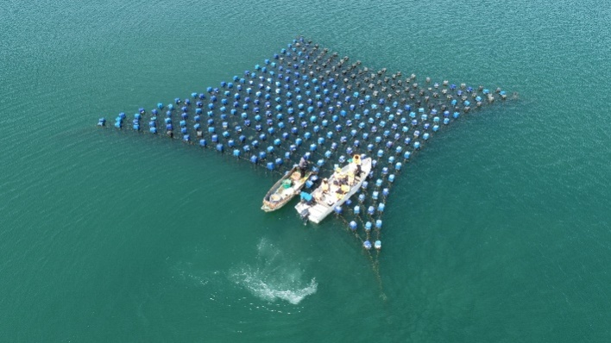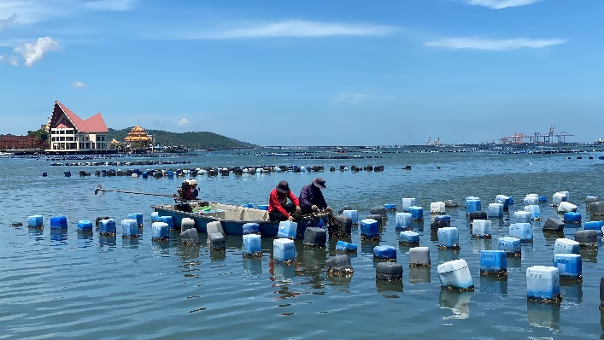

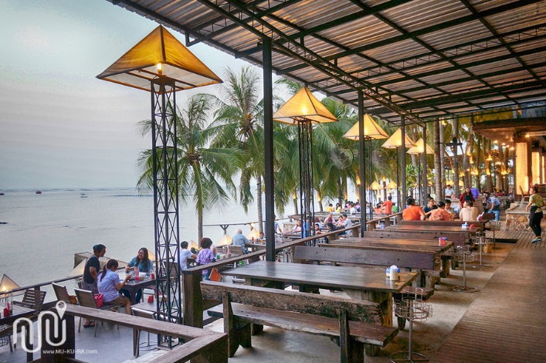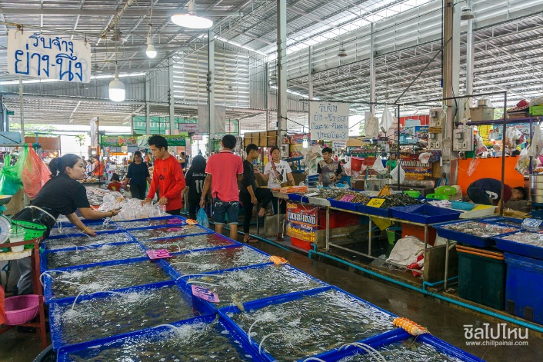

**October 21, 2023 (Saturday)**

9.00-17.00 hrs. Field Tripin Bangkok (TBA)

17.30-19.30 hrs. Farewell party

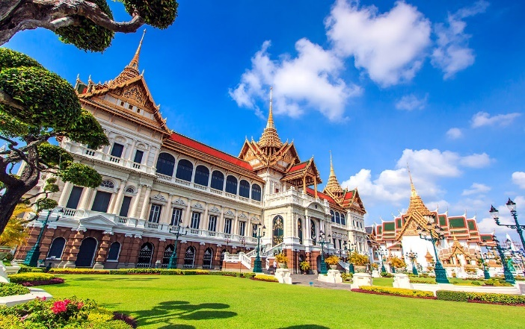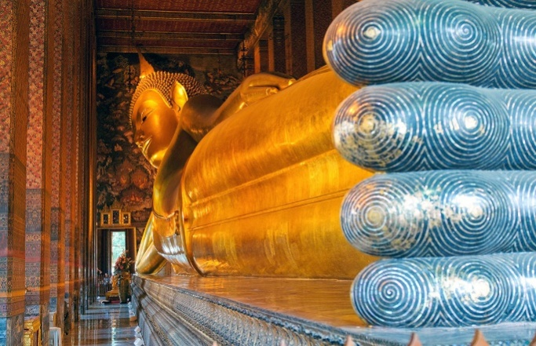

**Oct 22, 2023 (Sunday)**

Leaving

Location of the Conference

Kasetsart Golden Jubilee Administration and Information Center Building,

50 Kasetsart University, Lat Yao, Chatuchak, Bangkok 10900 Thailand

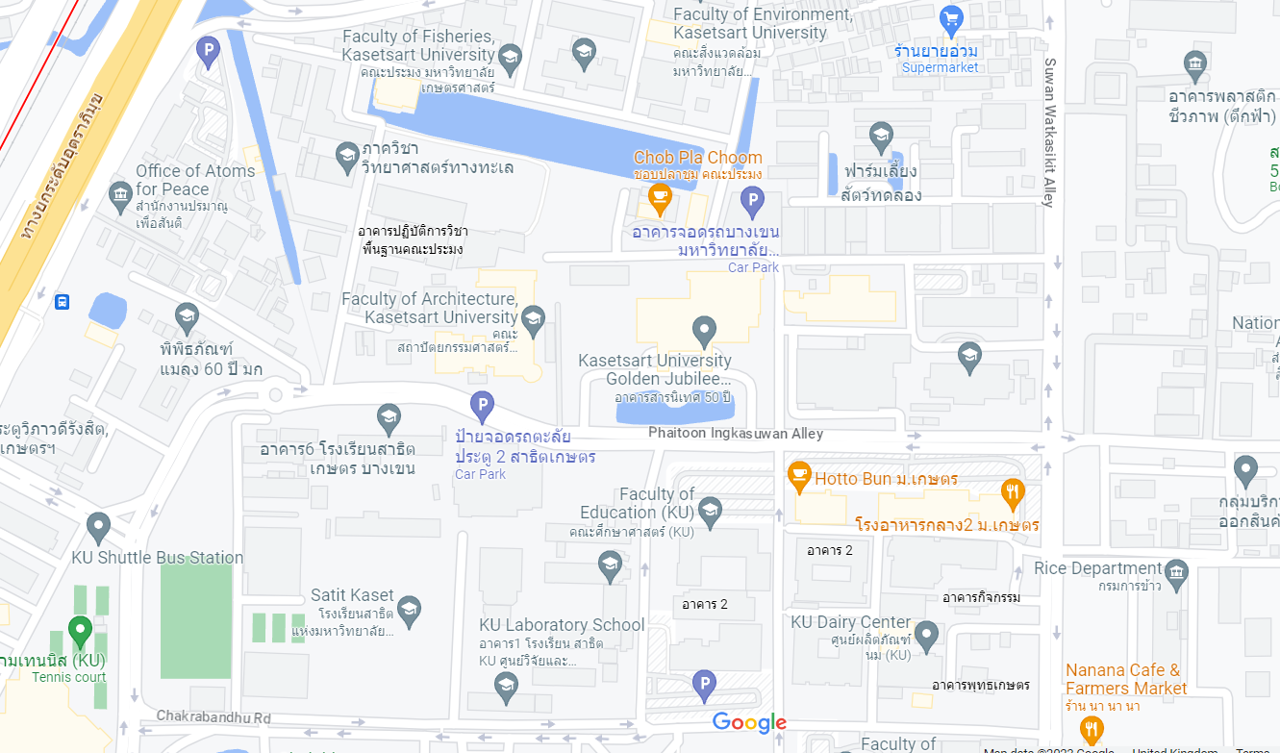

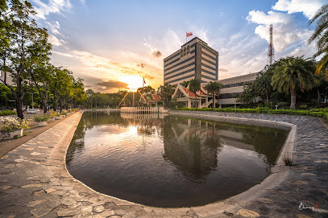

Location of the Suggested Hotel to Stay

Centara Grand at Central Plaza Ladprao Bangkok.

<https://www.centarahotelsresorts.com/centaragrand/cglb>

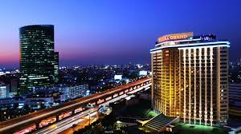

Suggestion of Direction

from Suvarnabhumi Airport to Centara Grand at Central Plaza Ladprao Bangkok by taxi

