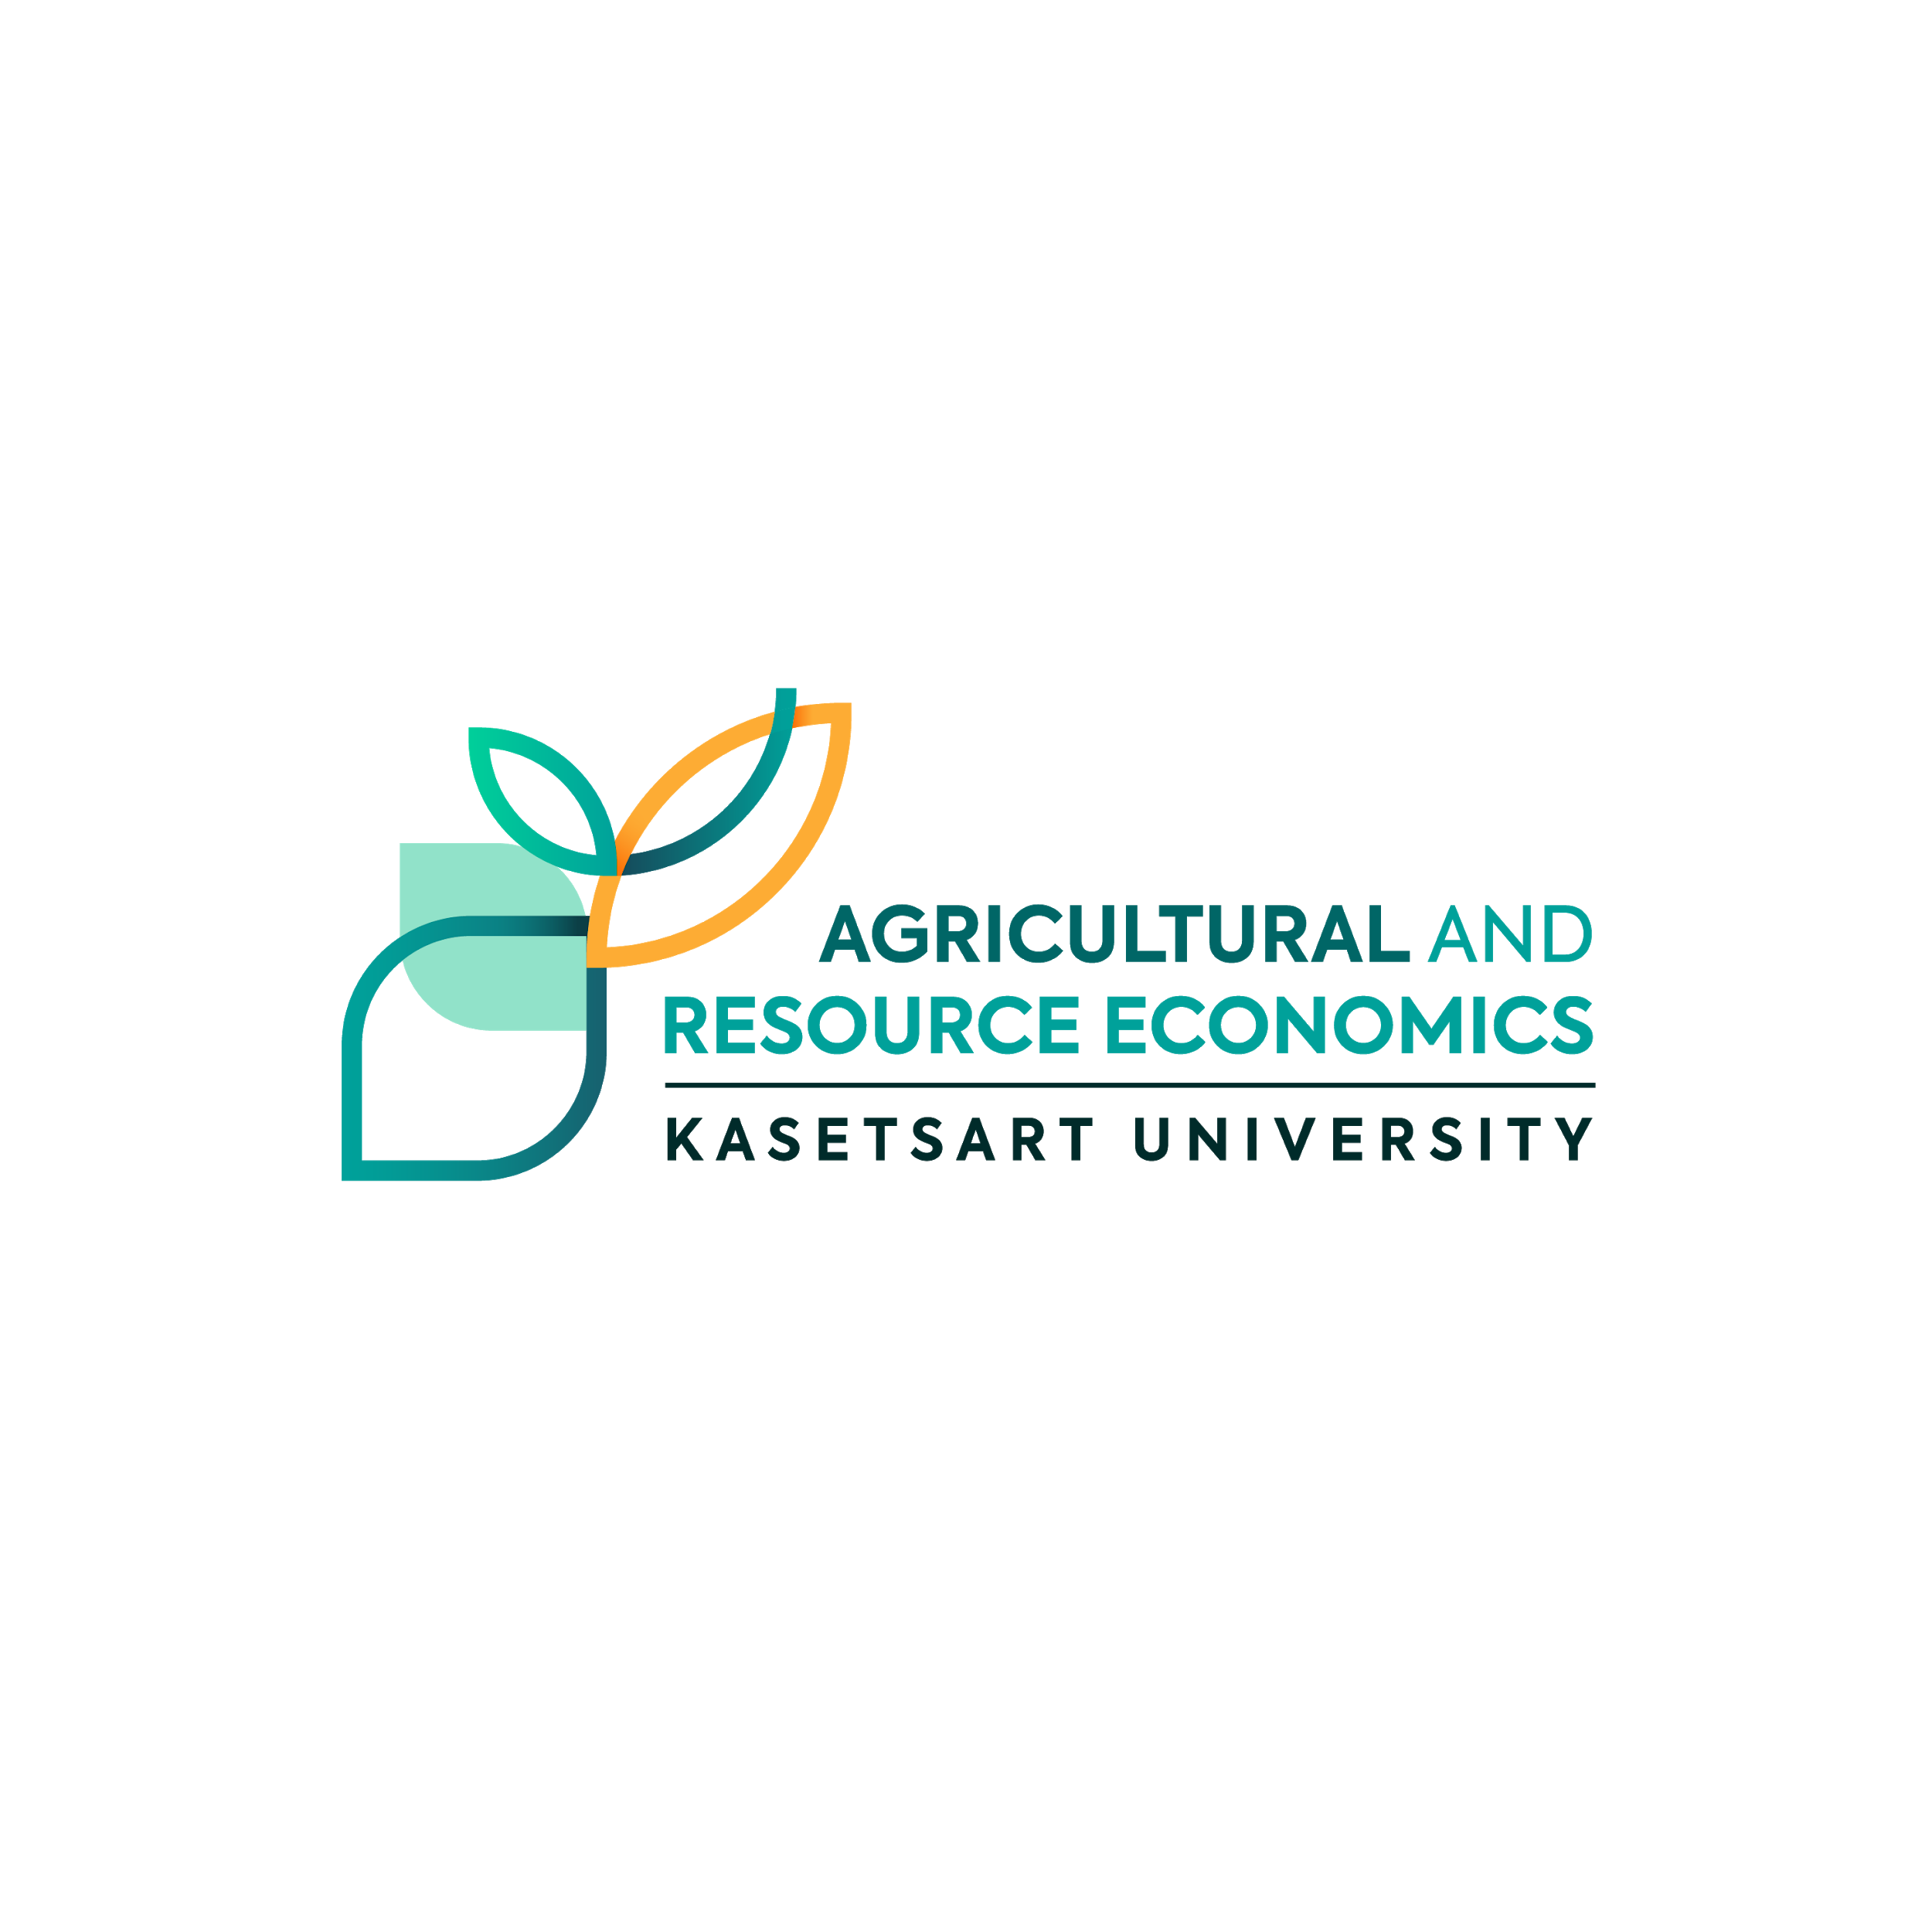

25 September 2021

**Dear,**

**Herbert Bayer**

GMO foods have been available to consumers since the early 1990s. Since then, the U.S. Food and Drug Administration (FDA), U.S. Environmental Protection Agency (EPA), and U.S. Department of Agriculture (USDA) have worked together to ensure that crops produced through genetic engineering are safe for people, animals, and the environment.

Despite there being a wide range of foods—GMO and non-GMO—available to consumers, there is some confusion around what GMOs are and how they are used in our food supply.

To help increase consumer understanding of GMOs, in 2017, Congress provided funding for an Agricultural Biotechnology Education and Outreach Initiative, which calls upon FDA to work with EPA and USDA to share science-based educational information about GMOs, beginning with answers to some basic GMO questions.



**Wilhelm Wagenfeld**

Ph.D. in Economics



Tel 0-2942-8650-51 , 02561-3467

Fax : 0-2579-9429

Email : appliedeconku@gmail.com

Website : agri.eco.ku.ac.th

**Department of Agricultural and Resource Economics,**

Faculty of Economics​ , Kasetsart University

50 Ngam Wong Wan Rd,

Ladyaow, Chatuchak, Bangkok 10900